**Neurology-3plex 테스트용 바코드 (2022.06.24 제작)**

**VEUDx LOT/V1/EZNE22062401/Neurology-3plex/221124/3_a3427.628697_b0.940849_c533837.496638_d39832549.230105/5_a3427.628697_b0.940849_c533837.496638_d39832549.230105/7_a3427.628697_b0.940849_c533837.496638_d39832549.230105**

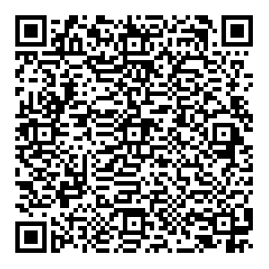

**VEUDx Strip/V1/EZNE22062401/Neurology-3plex/221124**

